.

**Dept of Artificial Intelligence and Machine Learning** | **Rajalakshmi Engineering College**

60

[04 - Iteration Control Structures](https://www.rajalakshmicolleges.net/moodle/course/view.php?id=84&section-4)

**Ex. No. : 4.1 Date:** 30/3/24

.

**Dept of Artificial Intelligence and Machine Learning** | **Rajalakshmi Engineering College**

61

**Register No.: 231501055 Name: Gunavazhagan B**

# [Factors of a number](https://www.rajalakshmicolleges.net/moodle/mod/quiz/view.php?id=5720)

Determine the factors of a number (i.e., all positive integer values that evenly divide into a number).

## For example:

|  |  |
| --- | --- |
| **Input** | **Result** |
| 20 | 1 2 4 5 10 20 |

**PROGRAM**

a=int(input())

for i in range(1,a+1): if (a%i==0):

print(i,end=’ ‘)

Output:

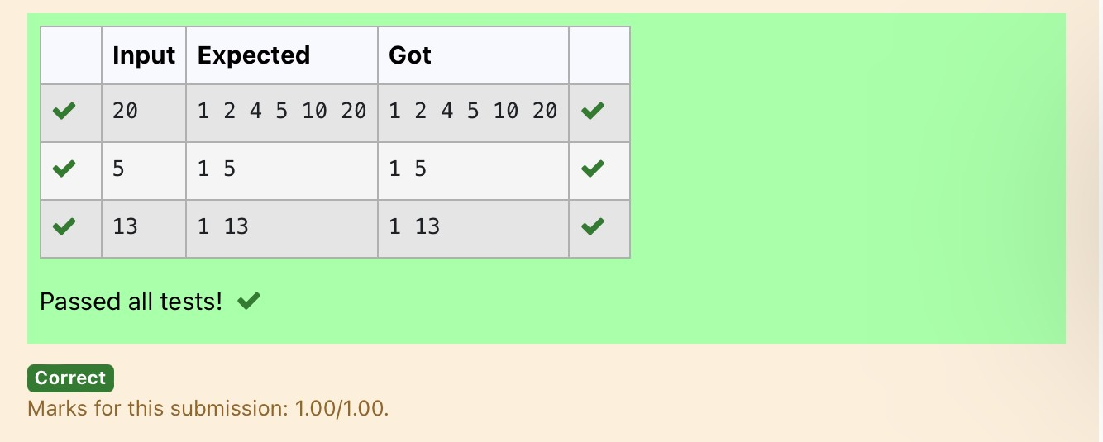

**Ex. No. : 4.2 Date:** 30/3/24

.

**Dept of Artificial Intelligence and Machine Learning** | **Rajalakshmi Engineering College**

62

**Register No.: 231501055 Name: Gunavazhagan B**

# [Non](https://www.rajalakshmicolleges.net/moodle/mod/quiz/view.php?id=5717) Repeated Digit Count

Write a program to find the count of non-repeated digits in a given number N. The number will be passed to the program as an input of type int.

Assumption: The input number will be a positive integer number >= 1 and <= 25000. Some examples are as below.

If the given number is 292, the program should return 1 because there is only 1 non-- repeated digit '9' in this number

If the given number is 1015, the program should return 2 because there are 2 non- repeated digits in this number, '0', and '5'.

If the given number is 108, the program should return 3 because there are 3 non-- repeated digits in this number, '1', '0', and '8'.

If the given number is 22, the function should return 0 because there are NO non-- repeated digits in this number.

## For example:

|  |  |
| --- | --- |
| **Input** | **Result** |
| 292 | 1 |
| 1015 | 2 |
| 108 | 3 |
| 22 | 0 |

**PROGRAM**

.

**Dept of Artificial Intelligence and Machine Learning** | **Rajalakshmi Engineering College**

63

num=int(input()) count=0 last=len(str(num)) for i in range(1,last):

temp=num%10 num=num//10

if (str(temp)not in str(num)): count+=1

if(len(str(num))==1 and count==last-1): print(count+1)

else:

print(count) Output:

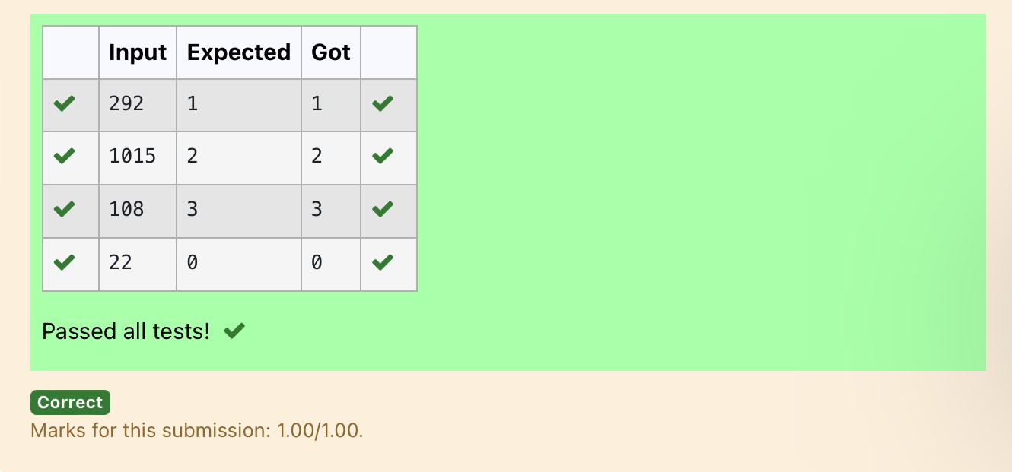

**Ex. No. : 4.3 Date:** 30/3/24

.

**Dept of Artificial Intelligence and Machine Learning** | **Rajalakshmi Engineering College**

64

**Register No.: 231501055 Name: Gunavazhagan B**

# Prime Checking

Write a program that finds whether the given number N is Prime or not. If the number is prime, the program should return 2 else it must return 1.

Assumption: 2 <= N <=5000, where N is the given number.

Example1: if the given number N is 7, the method must return 2 Example2: if the given number N is 10, the method must return 1

## For example:

|  |  |
| --- | --- |
| **Input** | **Result** |
| 7 | 2 |
| 10 | 1 |

**PROGRAM**

a=int(input()) count=0

for i in range(2,a): if (a%i==0):

count+=1 if(count==0):

print(“2”)

else:

print(“1”)

# Output:

.

**Dept of Artificial Intelligence and Machine Learning** | **Rajalakshmi Engineering College**

65

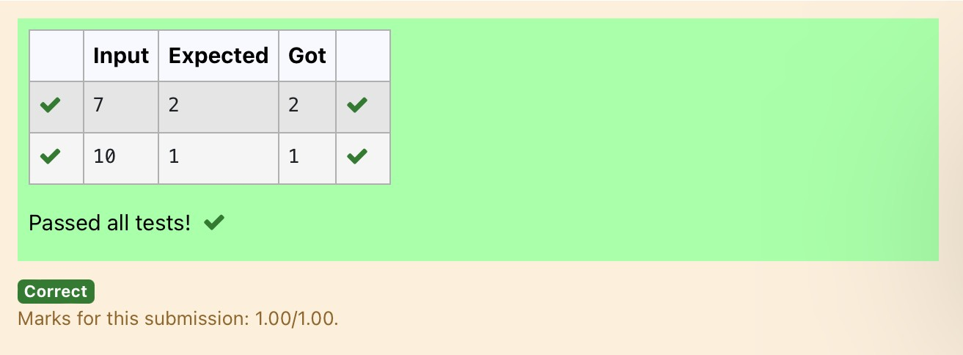

.

**Dept of Artificial Intelligence and Machine Learning** | **Rajalakshmi Engineering College**

66

**Ex. No. : 4.4 Date:** 30/3/24

**Register No.: 231501055 Name: Gunavazhagan B**

# Next Perfect Square

Given a number N, find the next perfect square greater than N.

Input Format:

Integer input from stdin. Output Format:

Perfect square greater than N. Example Input:

10

Output:

16

**PROGRAM**

from math import sqrt num=int(input()) while True:

a=int(sqrt(num)) if(num==pow(a,2)):

print(num) break

else:

num+=1

# Output:

.

**Dept of Artificial Intelligence and Machine Learning** | **Rajalakshmi Engineering College**

67

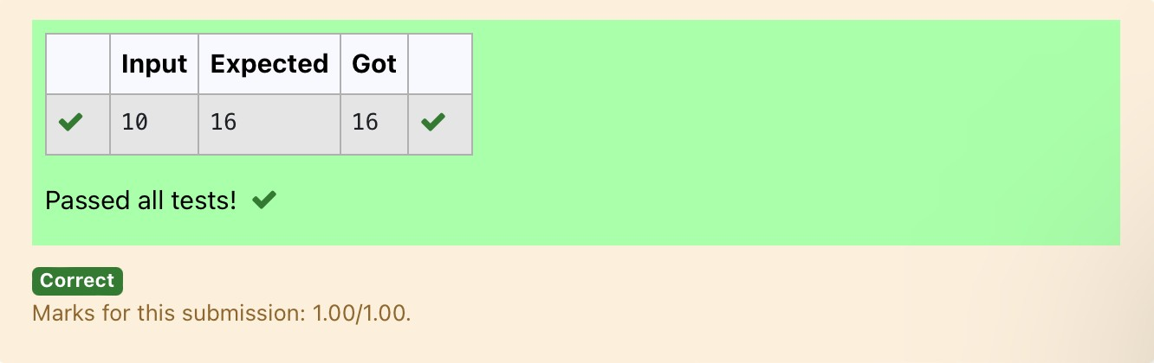

**Ex. No. : 4.5 Date:** 30/3/24

.

**Dept of Artificial Intelligence and Machine Learning** | **Rajalakshmi Engineering College**

68

**Register No.: 231501055 Name: Gunavazhagan B**

# Nth Fibonacci

Write a [program](https://www.rajalakshmicolleges.net/moodle/mod/quiz/view.php?id=3478) to return the nth number in the fibonacci series. The value of N will be passed to the [program](https://www.rajalakshmicolleges.net/moodle/mod/quiz/view.php?id=3478) as input.

NOTE: Fibonacci series looks like –

0, 1, 1, 2, 3, 5, 8, 13, 21, 34, 55, . . . and so on.

i.e. Fibonacci series starts with 0 and 1, and continues generating the next number as the sum of the previous two numbers.

* first Fibonacci number is 0,
* second Fibonacci number is 1,
* third Fibonacci number is 1,
* fourth Fibonacci number is 2,
* fifth Fibonacci number is 3,
* sixth Fibonacci number is 5,
* seventh Fibonacci number is 8, and so on.

**For example:** Input Output 7 8

**PROGRAM**

a=int(input()) b=0

c=1 d=0

for i in range(3,a+1): d=c+b

b=c c=d print(d)

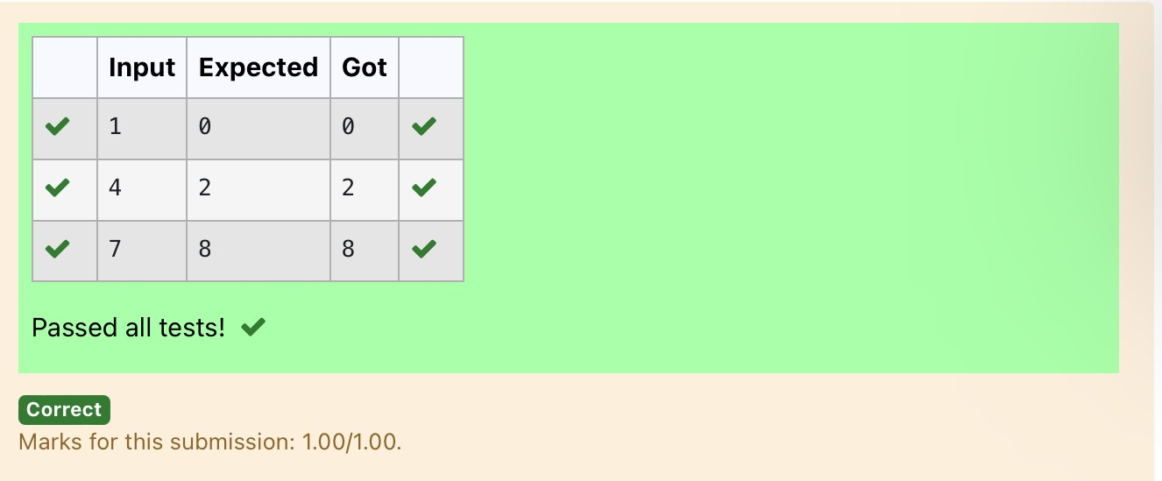**Output:**

.

**Dept of Artificial Intelligence and Machine Learning** | **Rajalakshmi Engineering College**

69

**Dept of Artificial Intelligence and Machine Learning** | **Rajalakshmi Engineering College**

70

**Ex. No. : 4.6 Date:**

**Register No.: 231501055 Name: Gunavazhagan B**

# Disarium Number

A Number is said to be Disarium number when the sum of its digit raised to the power of their respective positions becomes equal to the number itself. Write a [program](https://www.rajalakshmicolleges.net/moodle/mod/quiz/view.php?id=3478) to print number is Disarium or not.

Input Format:

Single Integer Input from stdin.

Output Format:

Yes or No. Example Input:

175

Output:

Yes Explanation

1^1 + 7^2 +5^3 = 175

Example Input: 123

Output:

No

For Example:

Input Result

175 Yes

123 No

.

.

**Dept of Artificial Intelligence and Machine Learning** | **Rajalakshmi Engineering College**

71

**PROGRAM**

num=int(input()) last=len(str(num)) temp=num Sum=0

for i in range(0,last): n=temp%10 temp=temp//10 sum=sum+(pow(n,last-i))

if (sum==num):

print(“Yes”)

else:

print(“No”)

# Output:

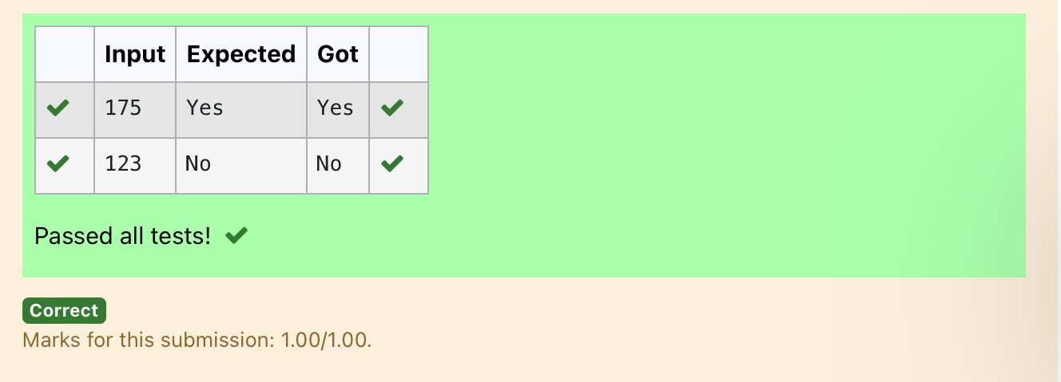

**Ex. No. : 4.7 Date:** 30/3/24

.

**Dept of Artificial Intelligence and Machine Learning** | **Rajalakshmi Engineering College**

72

**Register No.: 231501055 Name: Gunavazhagan B**

# Sum of Series

Write a program to find the sum of the series 1 +11 + 111 + 1111 + . . . + n terms (n will be given as input from the user and sum will be the output)

Sample Test Cases Test Case 1

Input 4

Output 1234

Explanation:

As input is 4, have to take 4 terms. 1 + 11 + 111 + 1111

Test Case 2 Input

6

Output 123456

## For example:

|  |  |
| --- | --- |
| **Input** | **Result** |
| 3 | 123 |

**PROGRAM**

.

**Dept of Artificial Intelligence and Machine Learning** | **Rajalakshmi Engineering College**

73

num=int(input()) sum1=0

for i in range(1,num+1): st=’1’*i sum1=sum1+int(st)

print(sum1)

Output:

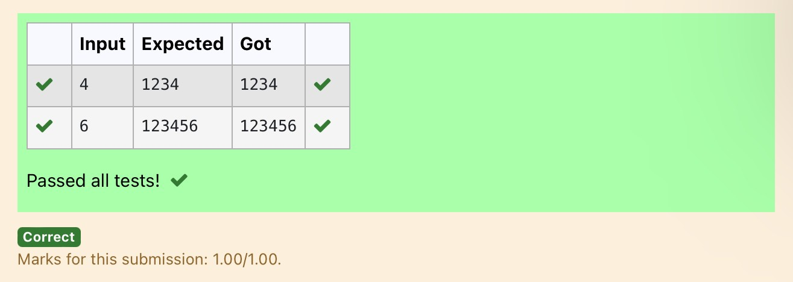

**Ex. No. : 4.8 Date:** 30/3/24

**Dept of Artificial Intelligence and Machine Learning** | **Rajalakshmi Engineering College**

74

**Register No.: 231501055 Name: Gunavazhagan B**

# Unique Digit Count

Write a program to find the count of unique digits in a given number N. The number will be passed to the program as an input of type int.

Assumption: The input number will be a positive integer number >= 1 and <= 25000. For e.g.

If the given number is 292, the program should return 2 because there are only 2 unique digits '2' and '9' in this number

If the given number is 1015, the program should return 3 because there are 3 unique digits in this number, '1', '0', and '5'.

## For example:

|  |  |
| --- | --- |
| **Input** | **Result** |
| 292 | 2 |
| 1015 | 3 |

**PROGRAM**

num=int(input()) count=0 last=len(str(num)) for i in range(1,last):

n=num%10 num=num//10

if (str(n)not in str(num)): count+=1

print(count+1)

.

**Output:**

.

**Dept of Artificial Intelligence and Machine Learning** | **Rajalakshmi Engineering College**

75

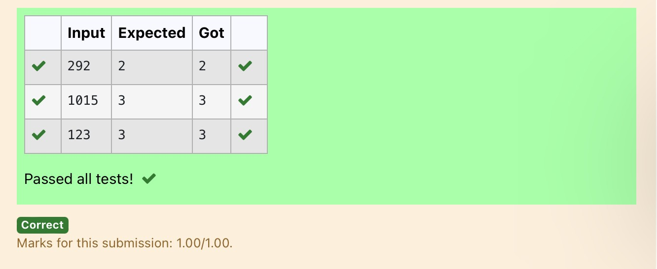

**Dept of Artificial Intelligence and Machine Learning** | **Rajalakshmi Engineering College**

76

**Ex. No. : 4.9 Date:** 30/3/24

**Register No.: 231501055 Name: Gunavazhagan B**

# Product of single digit

Given a positive integer N, check whether it can be represented as a product of single digit numbers.

Input Format:

Single Integer input. Output Format:

Output displays Yes if condition satisfies else prints No.

For Example: Input Output

14 Yes

13 No

**PROGRAM**

a=int(input()) count=0

for i in range(1,10):

for j in range(1,10): if (i*j==a):

print(“Yes”) count+=1 break

if(count>0): break

if(count==0):

print(“No”)

.

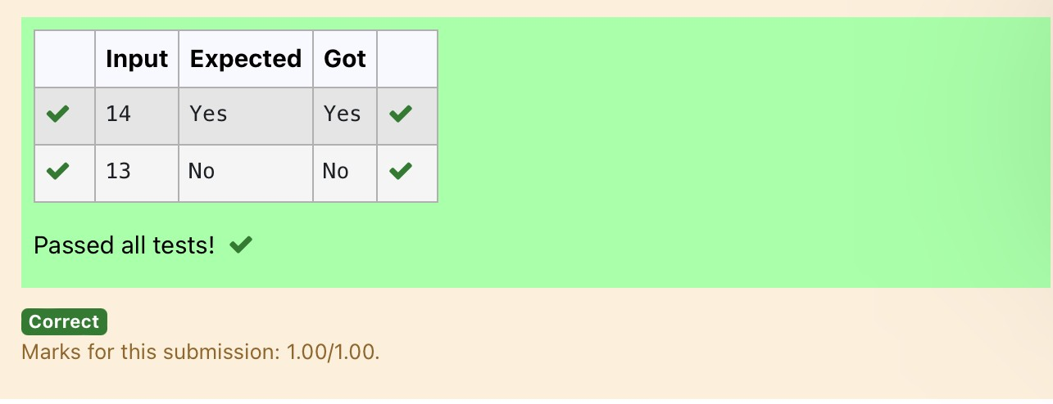Output:

.

**Dept of Artificial Intelligence and Machine Learning** | **Rajalakshmi Engineering College**

77

**Ex. No. : 4.10 Date:** 30/3/24

**Dept of Artificial Intelligence and Machine Learning** | **Rajalakshmi Engineering College**

78

**Register No.: 231501055 Name: Gunavazhagan B**

# Perfect Square After adding One

Given an integer N, check whether N the given number can be made a perfect square after adding 1 to it.

Input Format: Single integer input. Output Format:

Yes or No.

Example Input:

24

Output:

Yes

Example Input:

26

Output:

No

## For example:

|  |  |
| --- | --- |
| **Input** | **Result** |
| 24 | Yes |

**PROGRAM**

from math import sqrt num=int(input()) fin=num+1 sq=int(sqrt(fin))

if (fin==pow(sq,2)):

print(“Yes”)

else:

print(“No”)

.

Output:

.

**Dept of Artificial Intelligence and Machine Learning** | **Rajalakshmi Engineering College**

79

